**Soul Website – Style**

**Colour Palette**

#2В2В2В 
#ЗС5А72 
#CF9901 

|  |  |  |
| --- | --- | --- |
| **Black**   * Page footer * Default text | **Blue**   * Main colour * H1 & H2 tags | **Mustard**   * Accent colour * Hyperlinks (black on hover) |

**Logo Use**

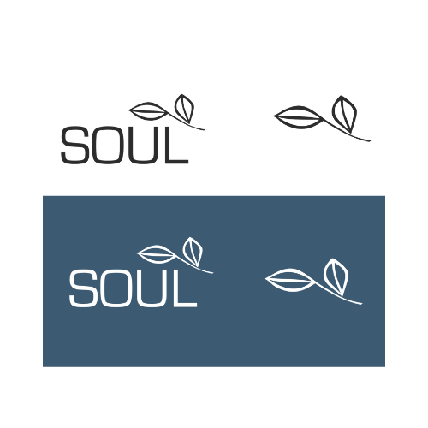

*Full logo*

* Usually appearing white with blue background
* Black main use for document printing

*Leaf only*

* Simplified for use where full logo isn’t required (e.g.
* Facebook/Instagram profile picture)

**Font**

* Eurostile – Headings, page titles and nav bar
* Sans-serif (e.g. Arial or Helvetica) for all other fonts.

**Other**

* Image sizes to be decided (NFD advice?)
* Icons (e.g. footer) have been made and will be provided (Tim)
* Eurostile font file to be provided (Tim)
* Content for pages will be written by Soul when required

**Home Page**

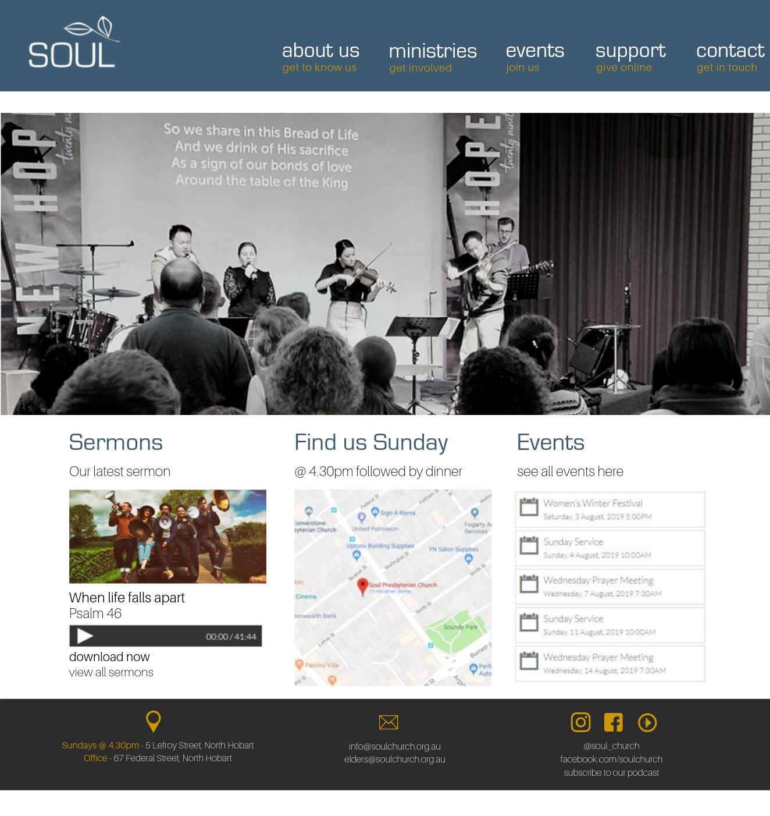

**Notes**

* Sermon image = sermon series
* Events pulls from elvanto
* Feature image – not too big
* About us = drop down menu
* Ministries = drop down menu
* Events = To events page
* Support = To give page
* Contact = To contact page

**Standard Page Design**soulchurch.org.au

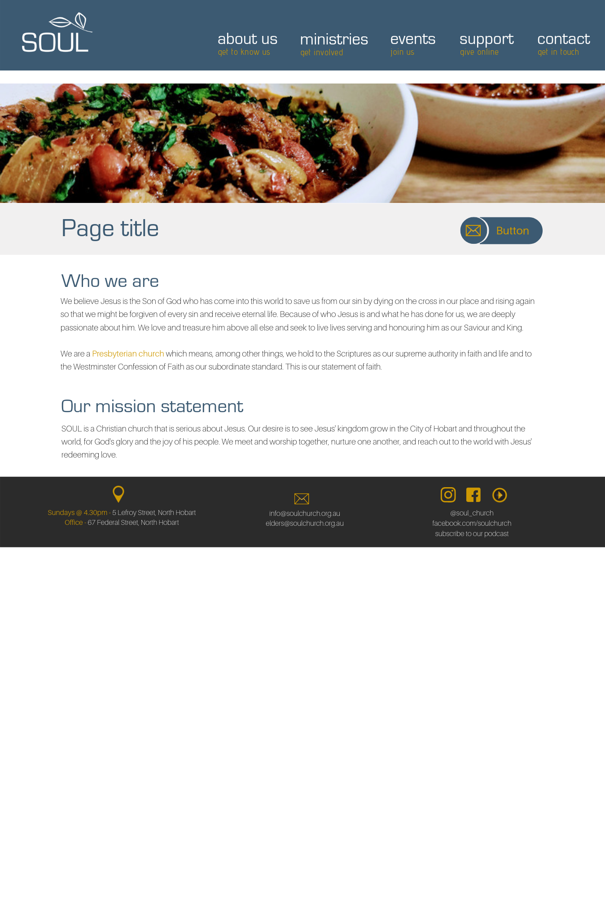

**Notes**

* All pages have a smaller uploaded feature image
* Page title has a grey background container
* Text has 1.5 spacing
* Any images inserted are automatically right aligned
* Pages have the option to add a “call to action button” (top right). This is a button with custom text and chosen hyperlink. Main use for redirecting to related content (e.g. Contact page links to eNews subscribe & sermon page to podcast). Flexible on design

**Contact Us**soulchurch.org.au/contact

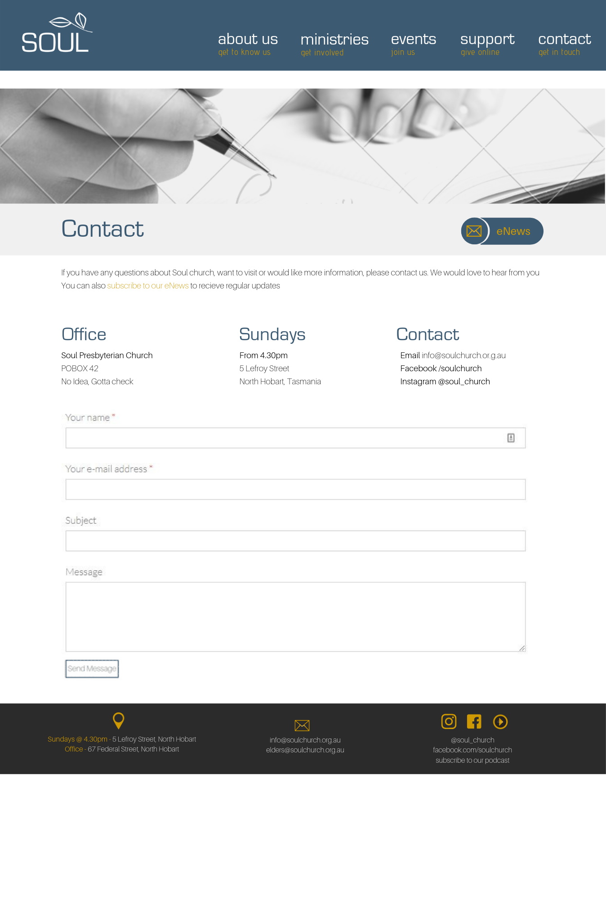

**Sermons**soulchurch.org.au/sermons

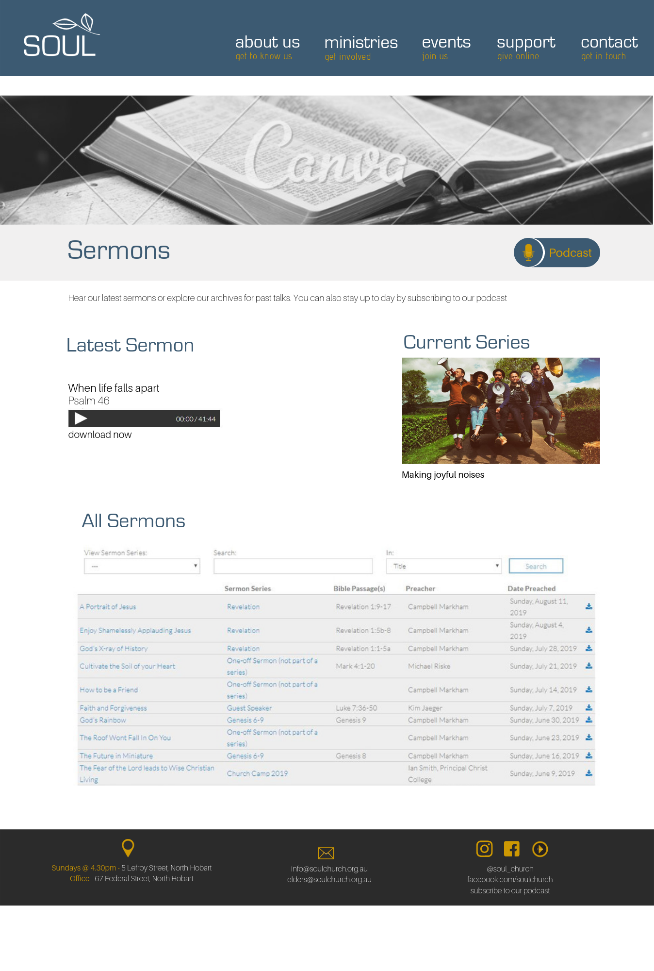

**Give**soulchurch.org.au/give

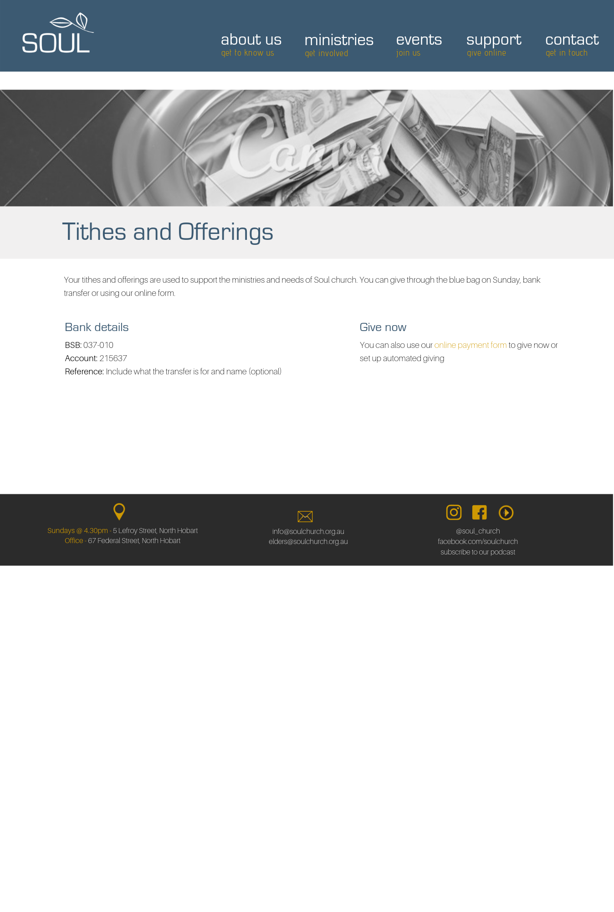

**Events**soulchurch.org.au/events

